***LENOVO@Orbs-On-Puri*** MINGW64 ~

$ ssh vendor@103.135.74.146 -p 6622

***vendor@ubuntu22:~$*** apt list --installed

***vendor@ubuntu22:~$*** sudo apt update

sudo apt install wget ca-certificates -y

***vendor@ubuntu22:~$*** sudo apt update

sudo apt install postgresql-17 -y

***vendor@ubuntu22:~$*** sudo -u postgres psql

psql (17.4 (Ubuntu 17.4-1.pgdg22.04+2))

Type "help" for help.

postgres=# CREATE USER jodeqa WITH PASSWORD '@2103191108030702ff#DD';

CREATE DATABASE dynamic_law OWNER jodeqa;

GRANT ALL PRIVILEGES ON DATABASE dynamic_law TO jodeqa;

\q

CREATE ROLE

CREATE DATABASE

GRANT

***vendor@ubuntu22:~$*** sudo nano /etc/postgresql/17/main/postgresql.conf

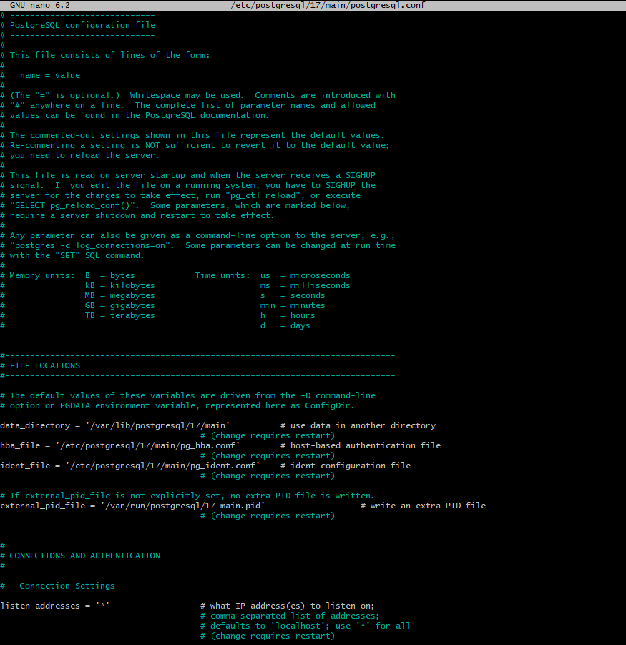

***vendor@ubuntu22:~$*** sudo nano /etc/postgresql/17/main/pg_hba.conf

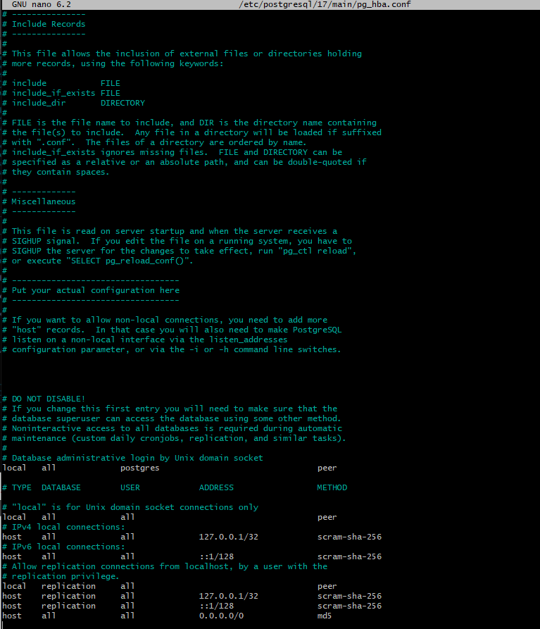

***vendor@ubuntu22:~$*** sudo systemctl restart postgresql

***vendor@ubuntu22:~$*** sudo ufw status

Status: inactive

***vendor@ubuntu22:~$*** sudo ufw delete allow 5432/tcp

Could not delete non-existent rule

Could not delete non-existent rule (v6)

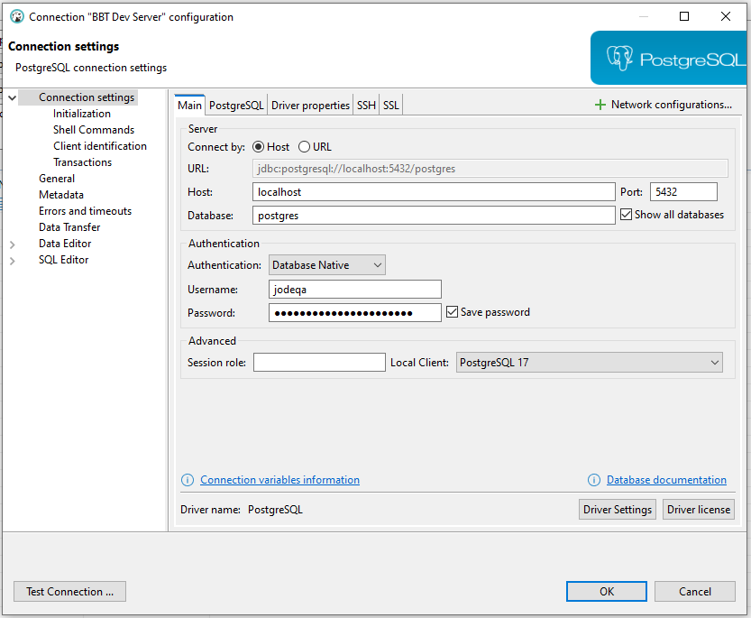

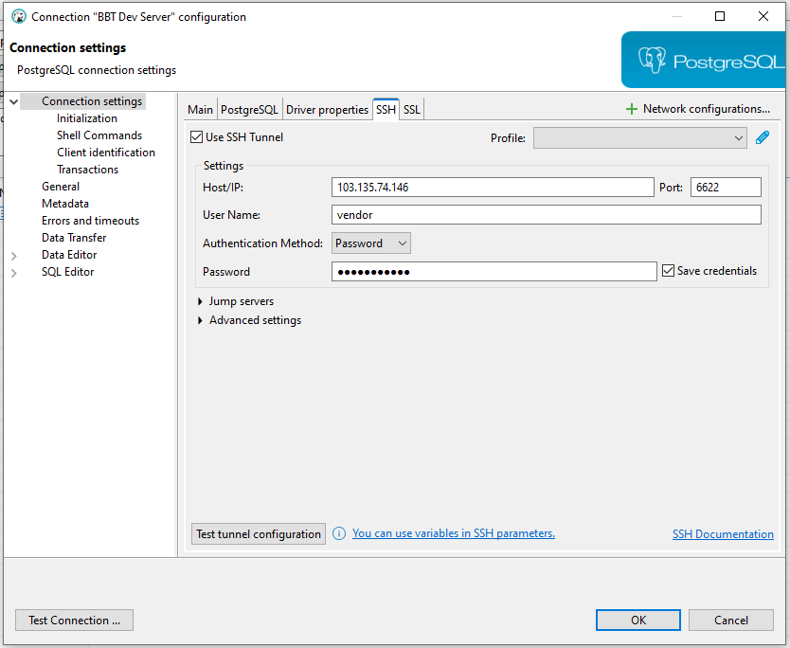

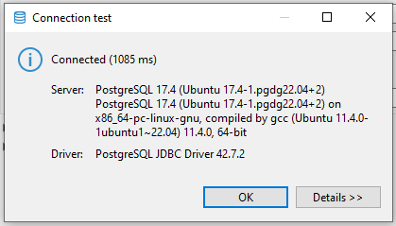

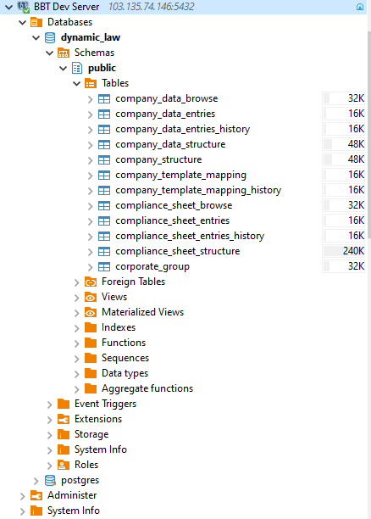

***vendor@ubuntu22:~$*** sudo add-apt-repository ppa:deadsnakes/ppa

sudo apt update

sudo apt install python3.12 python3.12-venv -y

***vendor@ubuntu22:~$*** sudo ufw allow 6622/tcp

sudo ufw allow 8000/tcp

sudo ufw enable

/usr/lib/python3/dist-packages/ufw/common.py:224: SyntaxWarning: invalid escape sequence '\d'

elif re.match('^\d+$', p):

/usr/lib/python3/dist-packages/ufw/util.py:483: SyntaxWarning: invalid escape sequence '\.'

quads = re.split('\.', nm)

/usr/lib/python3/dist-packages/ufw/util.py:745: SyntaxWarning: invalid escape sequence '\s'

tmp = re.split('\s', out)

/usr/lib/python3/dist-packages/ufw/parser.py:231: SyntaxWarning: invalid escape sequence '\d'

if not re.match('^\d([0-9,:]*\d+)*$', port):

/usr/lib/python3/dist-packages/ufw/parser.py:357: SyntaxWarning: invalid escape sequence '\d'

elif not re.match('^\d([0-9,:]*\d+)*$', tmp):

Rules updated

Rules updated (v6)

Rules updated

Rules updated (v6)

Command may disrupt existing ssh connections. Proceed with operation (y|n)? y

Firewall is active and enabled on system startup

***vendor@ubuntu22:~$*** mkdir -p dynamic_law/{_doc,routes,services,templates,static,uploaded_files}

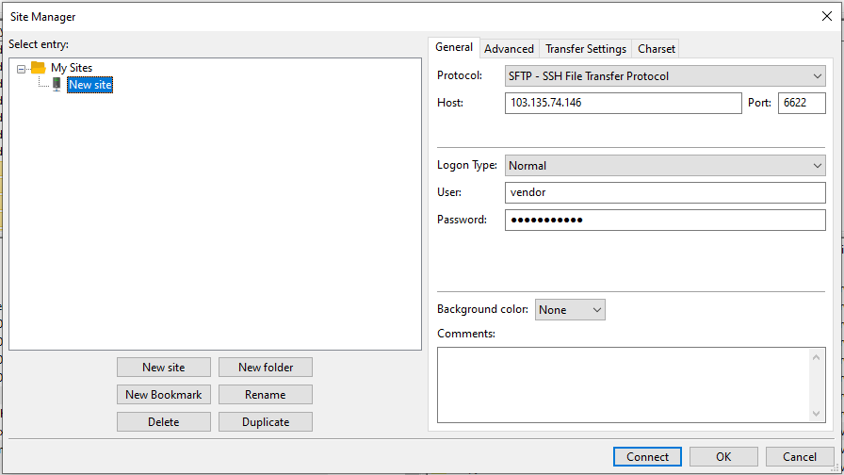

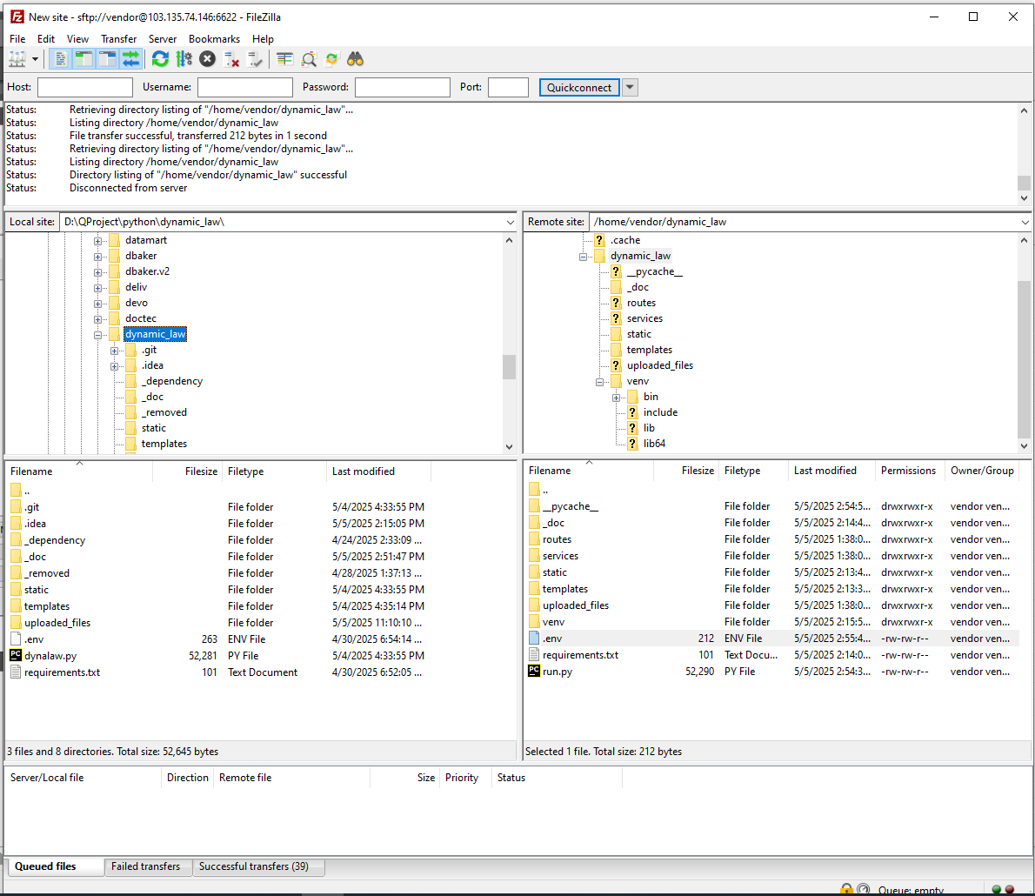

***vendor@ubuntu22:~$*** cd ~/dynamic_law

python3.12 -m venv venv

source venv/bin/activate

sudo apt install build-essential libpq-dev -y

pip install -r requirements.txt

pip install gunicorn

gunicorn -w 4 -b 0.0.0.0:8000 run:app

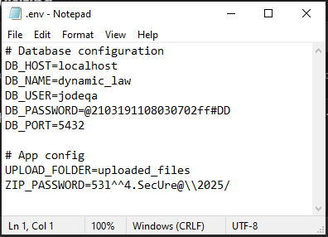s 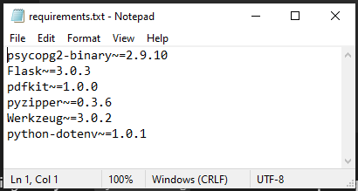

**vendor@ubuntu22:~$** sudo nano /etc/nginx/sites-enabled/appdev-lawfirm.ofon.id

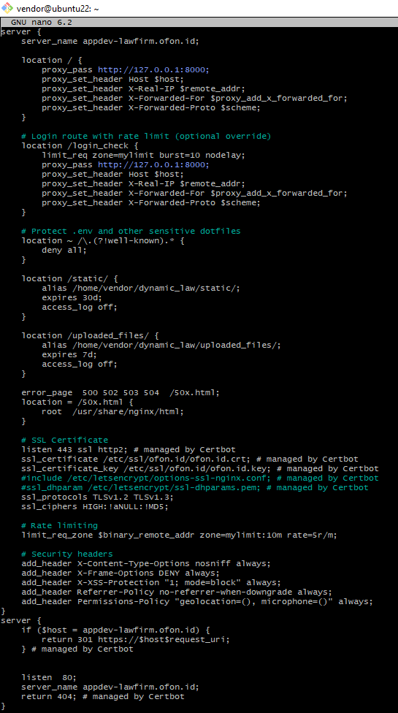

server {

server_name appdev-lawfirm.ofon.id;

location / {

proxy_pass http://127.0.0.1:8000;

proxy_set_header Host $host;

proxy_set_header X-Real-IP $remote_addr;

proxy_set_header X-Forwarded-For $proxy_add_x_forwarded_for;

proxy_set_header X-Forwarded-Proto $scheme;

}

# Login route with rate limit (optional override)

location /login_check {

proxy_pass http://127.0.0.1:8000;

proxy_set_header Host $host;

proxy_set_header X-Real-IP $remote_addr;

proxy_set_header X-Forwarded-For $proxy_add_x_forwarded_for;

proxy_set_header X-Forwarded-Proto $scheme;

}

# Protect .env and other sensitive dotfiles

location ~ /\.(?!well-known).* {

deny all;

}

location /static/ {

alias /home/vendor/dynamic_law/static/;

expires 30d;

access_log off;

}

location /uploaded_files/ {

alias /home/vendor/dynamic_law/uploaded_files/;

expires 7d;

access_log off;

}

error_page 500 502 503 504 /50x.html;

location = /50x.html {

root /usr/share/nginx/html;

}

# SSL Certificate

listen 443 ssl http2; # managed by Certbot

ssl_certificate /etc/ssl/ofon.id/ofon.id.crt; # managed by Certbot

ssl_certificate_key /etc/ssl/ofon.id/ofon.id.key; # managed by Certbot

#include /etc/letsencrypt/options-ssl-nginx.conf; # managed by Certbot

#ssl_dhparam /etc/letsencrypt/ssl-dhparams.pem; # managed by Certbot

ssl_protocols TLSv1.2 TLSv1.3;

ssl_ciphers HIGH:!aNULL:!MD5;

# Security headers

add_header X-Content-Type-Options nosniff always;

add_header X-Frame-Options DENY always;

add_header X-XSS-Protection "1; mode=block" always;

add_header Referrer-Policy no-referrer-when-downgrade always;

add_header Permissions-Policy "geolocation=(), microphone=()" always;

}

server {

if ($host = appdev-lawfirm.ofon.id) {

return 301 https://$host$request_uri;

} # managed by Certbot

listen 80;

server_name appdev-lawfirm.ofon.id;

return 404; # managed by Certbot

}

**vendor@ubuntu22:~$** sudo ln -s /etc/nginx/sites-available/appdev-lawfirm.ofon.id /etc/nginx/sites-enabled/

sudo nginx -t

sudo systemctl reload nginx

**vendor@ubuntu22:~$** sudo nano /etc/systemd/system/dynamic_law.service

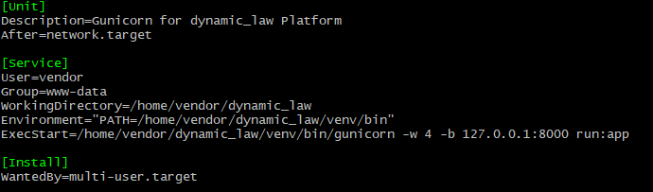

[Unit]

Description=Gunicorn for dynamic_law Platform

After=network.target

[Service]

User=vendor

Group=www-data

WorkingDirectory=/home/vendor/dynamic_law

Environment="PATH=/home/vendor/dynamic_law/venv/bin"

ExecStart=/home/vendor/dynamic_law/venv/bin/gunicorn -w 4 -b 127.0.0.1:8000 run:app

[Install]

WantedBy=multi-user.target

**vendor@ubuntu22:~$** sudo systemctl daemon-reexec

sudo systemctl daemon-reload

sudo systemctl enable dynamic_law

sudo systemctl start dynamic_law

**vendor@ubuntu22:~$** sudo systemctl start dynamic_law

**vendor@ubuntu22:~$** sudo ufw status

**vendor@ubuntu22:~$** sudo ufw allow 80

sudo ufw allow 443

sudo ufw reload

**vendor@ubuntu22:~$** sudo chmod -R o+r /home/vendor/dynamic_law/static

sudo find /home/vendor/dynamic_law/static -type d -exec chmod 755 {} \;

sudo chmod -R o+r /home/vendor/dynamic_law/uploaded_files

sudo find /home/vendor/ dynamic_law /uploaded_files -type d -exec chmod 755 {} \;

chmod o+x /home/vendor

chmod o+x /home/vendor/ dynamic_law

**vendor@ubuntu22:~$** sudo apt update

sudo apt install redis-server -y

sudo systemctl status redis

Step-by-Step Troubleshooting

**vendor@ubuntu22:~$** sudo systemctl status nginx

sudo systemctl start nginx

sudo systemctl status dynamic_law

sudo systemctl start dynamic_law

sudo ss -tulpn | grep :443

ls -l /etc/nginx/sites-enabled/